







Payment Gateway Troubleshooting Guide

Contents
Introduction 1
Resolving Payment Gateway Errors 1
PG Application Name Mismatch 2
Server Address Mismatch 3
Connection Timed Out 5
DLL Missing Errors 6
Missing SQL Folder 9
500 - Internal Server Error 10
Merchant Key is Empty 11
Incorrect Response URL 12
Payment Gateway Undefined 13
Contact Customer Care Executive 14
SPG Tag Checking...................................................................................................................................................... 15
Support 17
Copyright 18

Introduction

The Payment Gateway Troubleshooting Guide is intended to provide guidance to the Users, mainly Implementation Engineer Users (IE Users) when they face errors while configuring the Payment Gateway.
The User while configuring the Payment Gateway in the System might encounter some Known or Unknown errors. This document helps the User in understanding both the Payment Gateway errors and its solutions in the form of Screenshots.
The Screenshot approach helps the User in understanding the errors and its solutions in detail and coherent manner.

Resolving Payment Gateway Errors

Following are the most common errors faced by the Users.
- PG Application Name Mismatch
- Server Address Mismatch
- Connection Timed Out
- DLL Missing Errors
- Missing SQL Folder
- 500 - Internal Server Error
- Merchant Key Is Empty
- Incorrect Response URL
- Payment Gateway Undefined
- Contact Customer Care Executive
- SPG tag checking

PG Application Name Mismatch

Term | Details
Problem | Mismatch of Payment Gateway’s Application Name
Cause | This happens when there is a mismatch in the PG’s Application Name (declared in the Merchant Payment Gateway Screen) w.r.t to the PG Application name given in the Server.
Solution | Verify the PG Application name and make sure both the names are matching.

Example:
The following screenshots explain the above scenario:
Screenshot 1: Showing the PG Application Name as QC5103_AxisBank.
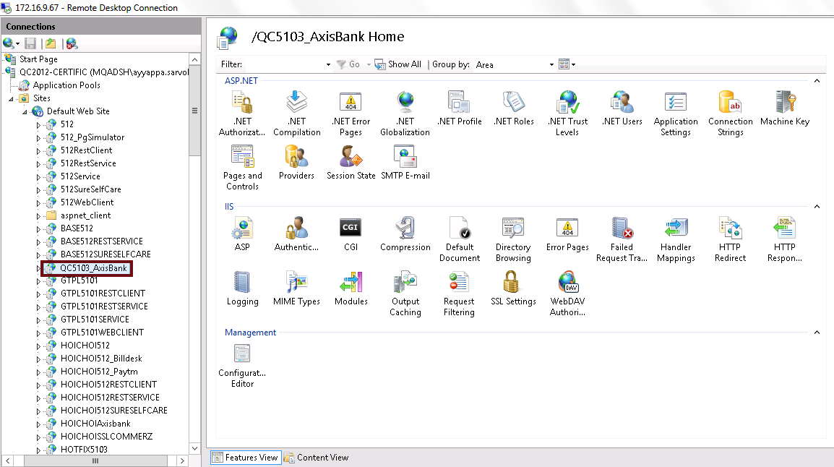
Screenshot 2: Showing the PG Application Name in Merchant Payment Gateway screen as QC51036_AxisBank (Mismatch).

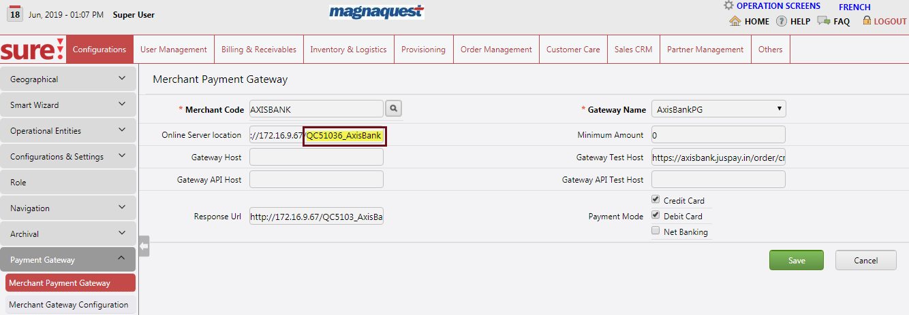
Screenshot 3: Showing the Error message caused by the above mismatch.
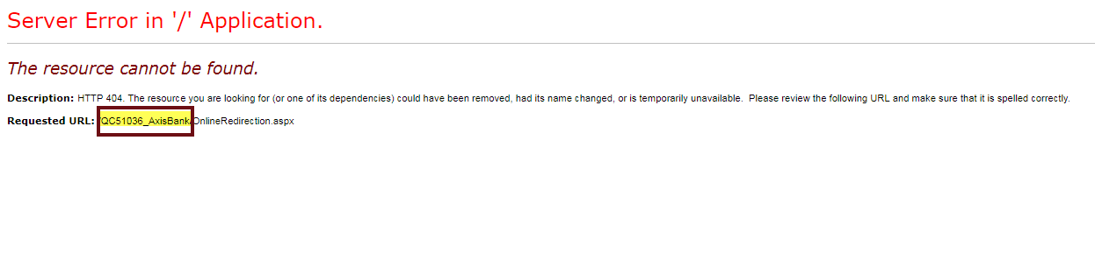

Server Address Mismatch

Term | Details
Problem | Server Address Mismatch
Cause | This happens when there is a mismatch in the Server’s Internet Protocol (IP) address declared in the Merchant Payment Gateway Screen w.r.t to the Server’s IP address.
Solution | Verify the Server’s IP address (I.e. Server where the Payment Gateway application is hosted) and make sure it should be given correctly in the Online Server Location field of the Merchant Payment Gateway screen.
Example:
The following screenshots explains the above scenario:

Screenshot 1: Showing the sample Internet Protocol (IP) address of the Server 172.16.9.67
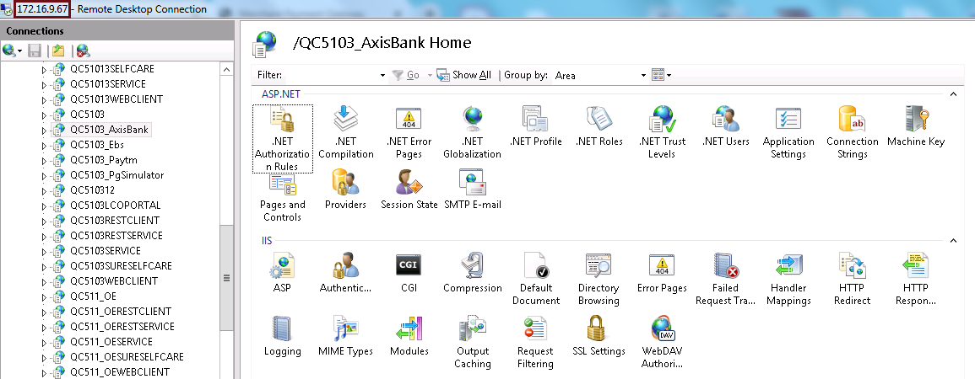
Screenshot 2: Showing the Internet Protocol (IP) address of the Server in the Merchant Payment Gateway screen as 172.16.9.671 (Mismatch)
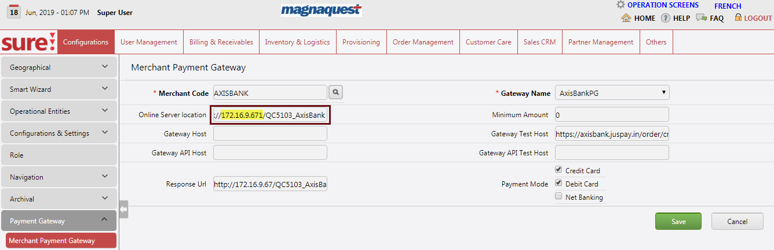

Screenshot 3: Showing the Error message caused by the above mismatch.
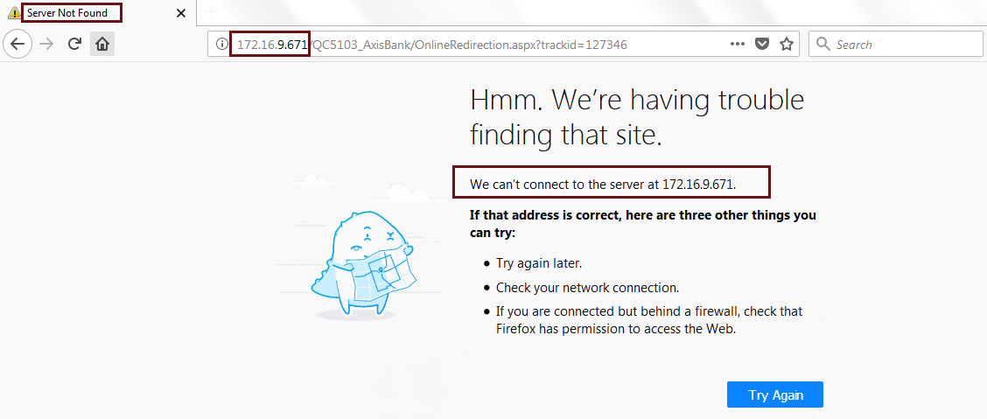

Connection Timed Out

Term | Details
Problem | The Connection Has Timed Out
Cause | These errors occur due to any one of the following reasons:  - This happens when the User is accessing the Private IP Server or when the User is not having access to the requested Server.  - When the Gateway URL is Inaccessible.  - And also when Online Server location value is Incorrect.
Solution | Make Sure you have the access to the Server.  In other words, if the Server is having Private IP and if you don’t have an access to the Server, then get the required permissions to access the Server from the competent authority (E.g. Admin Team).

Example:

Screenshot 1: Showing the Error message caused by the above mismatch.
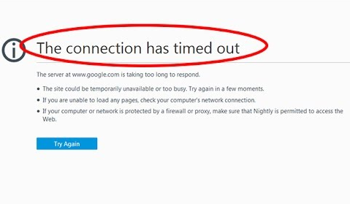

DLL Missing Errors

Term | Details
Problem | Error Occurred at Gateway  Error Occurred While Retrieving Online Payment Request Details
Cause | These errors occur due to any one of the following reasons:  - When .dll file (E.g. MySql.Data.dll, or Infragistics.Shared.v6.1.dll, or Infragistics.WebUI.Shared.v6.1.dll, or Infragistics.WebUI.UltraWebChart.v6.1.dll, or MSCaptcha.dll etc.) is missing in the bin folder of the Payment Gateway deploy.  - When SERVICE PROVIDER value is incorrectly given in the Web.Config file of the Payment Gateway deploy.  - When the Oracle version is incorrectly given in the Web.Config file of the Payment Gateway deploy.
Solution | Make sure the .dll files, SERVICE PROVIDER value, or the Oracle Version is proper and given correctly.  Please find the solutions below for above Issues.  - When the .dll file is missing, then take the respective missing dlls from the bin folder of the native portal deploy and replace the same in the bin folder of the Payment Gateway application deploy.  - Provide the correct Service Provider value in the Web.Config file of the Payment Gateway deploy.  - Please take the Oracle Version value from the Server’s ASSEMBLY.
Example: The following screenshots explains the above scenario:
Reason I:
Screenshot 1:
Showing MySql.Data.dll in the bin folder of the Payment Gateway deploy.
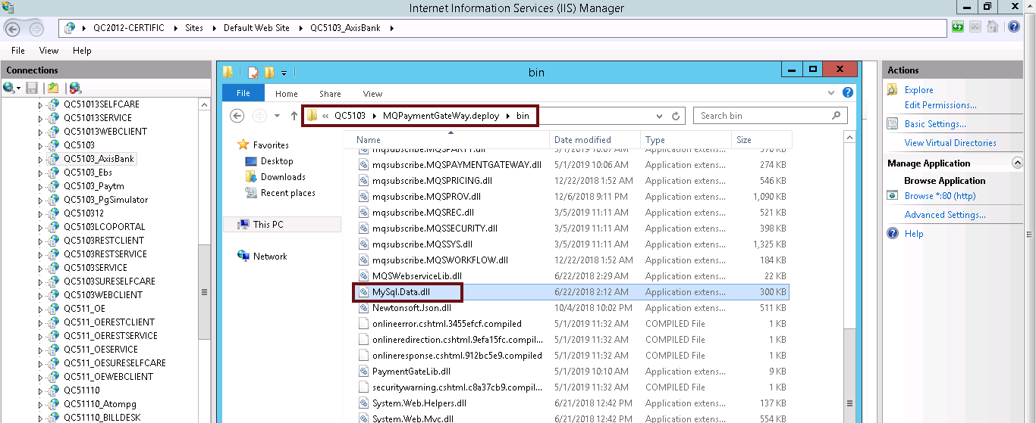
Screenshot 2:
Showing error message when MySql.Data.dll is missing in the bin folder of the Payment Gateway deploy.
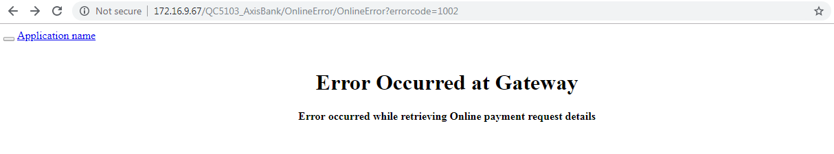
Screenshot 3:
Showing error message when Infragistics.WebUI.Shared.v6.1.dll is missing in the bin folder of the Payment Gateway deploy.
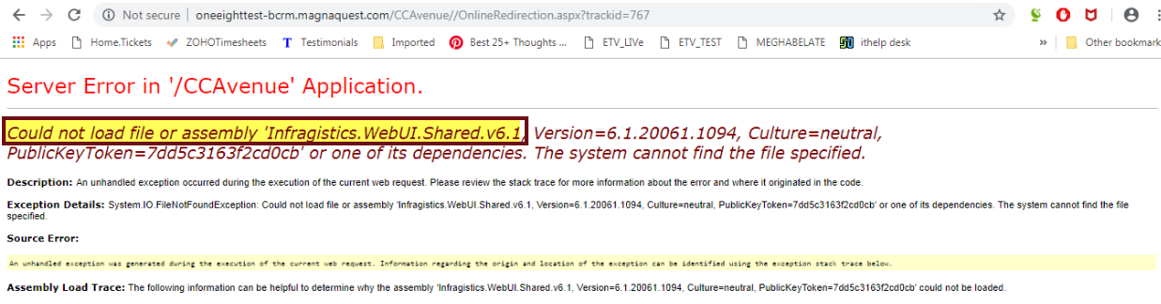
Note: Except MySql.Data.dll, all the other above mentioned dlls are Client Specific.

Reason - II
Screenshot 1: Showing SERVICEPROVIDER and its value in Web.Config file of PG deploy.
Here the Service Provider value should be QC5103 Instead of QC51031
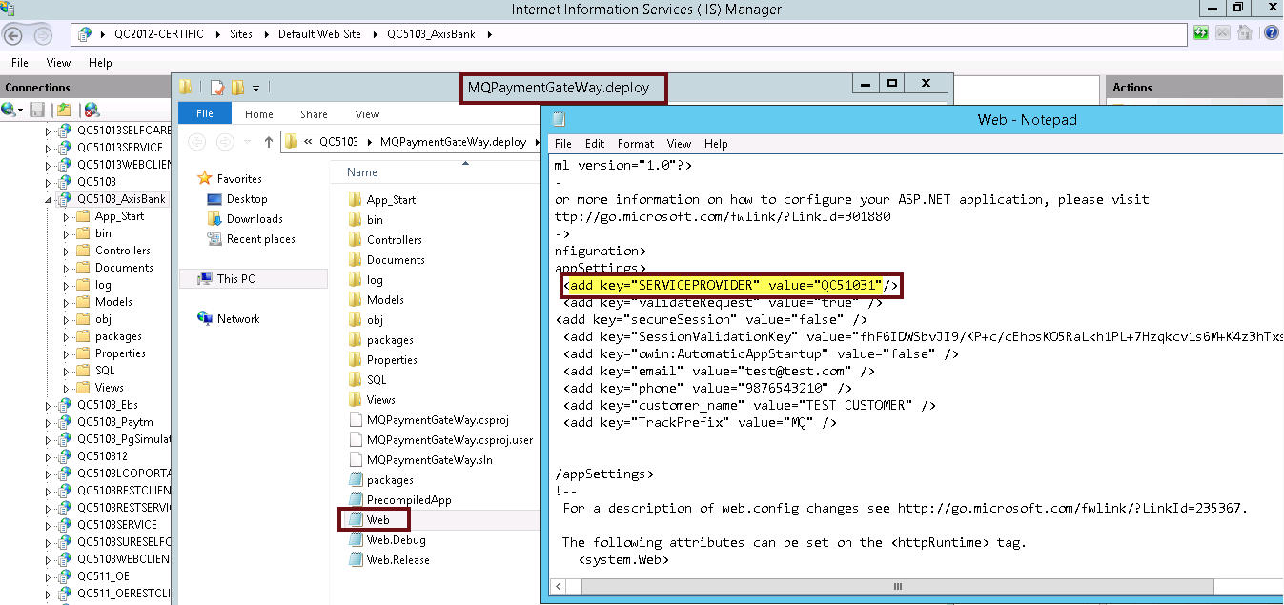
Reason III:
Screenshot 1: Showing the Oracle Version in the Web.Config file of PG deploy.

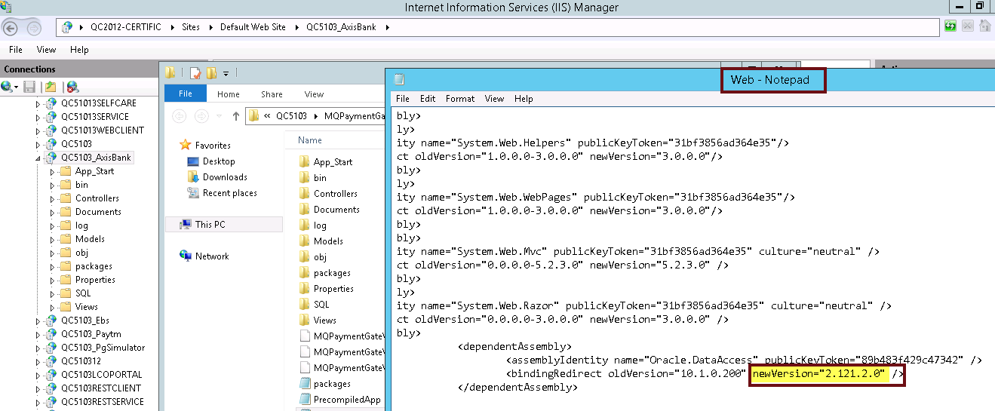
Note: For the above said 3 reasons the error message would be the same as shown in Screenshot 2 of Reason I.

Missing SQL Folder

Term | Details
Problem | Error Occurred at Gateway  Error Occurred While Retrieving Party Details
Cause | This happens when the SQL folder is missing in the Payment Gateway deploy.
Solution | Make Sure the SQL folder is present in the Payment Gateway deploy.  Please take the SQL folder from native portal deploy and replace it in Payment Gateway deploy.
Example:The following screenshots explains the above scenario:
Screenshot 1: Showing the SQL folder in the Payment Gateway deploy.
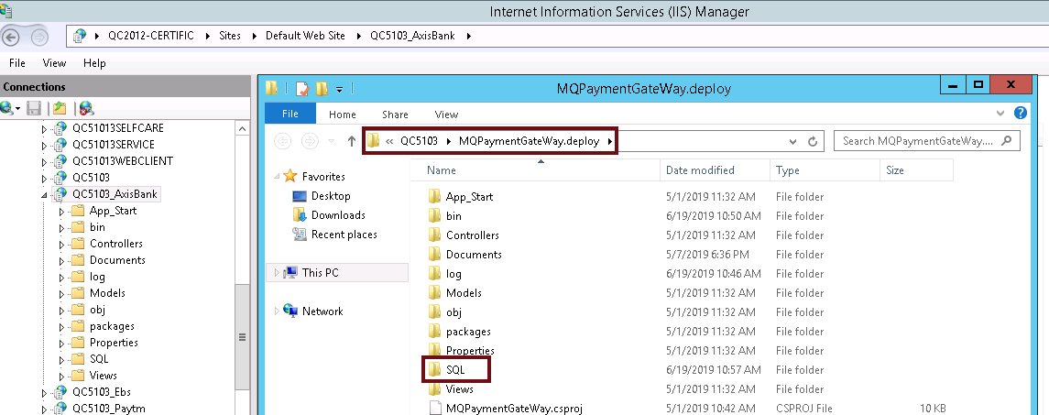
Screenshot 2: Showing the error message for the SQL folder missing in the Payment Gateway deploy.
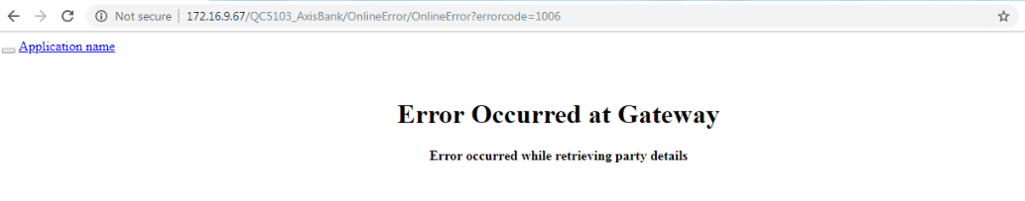

500 - Internal Server Error

Term | Details
Problem | Error Code 500 – Interval Server Error
Cause | The 5xx errors are the status codes returned by the server when the server encounters an unexpected condition which prevented it from fulfilling the request from a client.  The 500 Internal Server Error is the general catch all error when the server throws an exception. It is the error message when no more specific error message is suitable.
Solution | In this scenario (I.e. w.r.t Payment Gateway issues), kindly check whether the HTTP module is commented in the Payment Gateway deploy.  If it is uncommented, then we get the Internal Server Error.
Example:
The following screenshots explains the above scenario:
Screenshot 1: Showing the HTTP Modules in the Web.Config file of the Payment Gateway deploy.
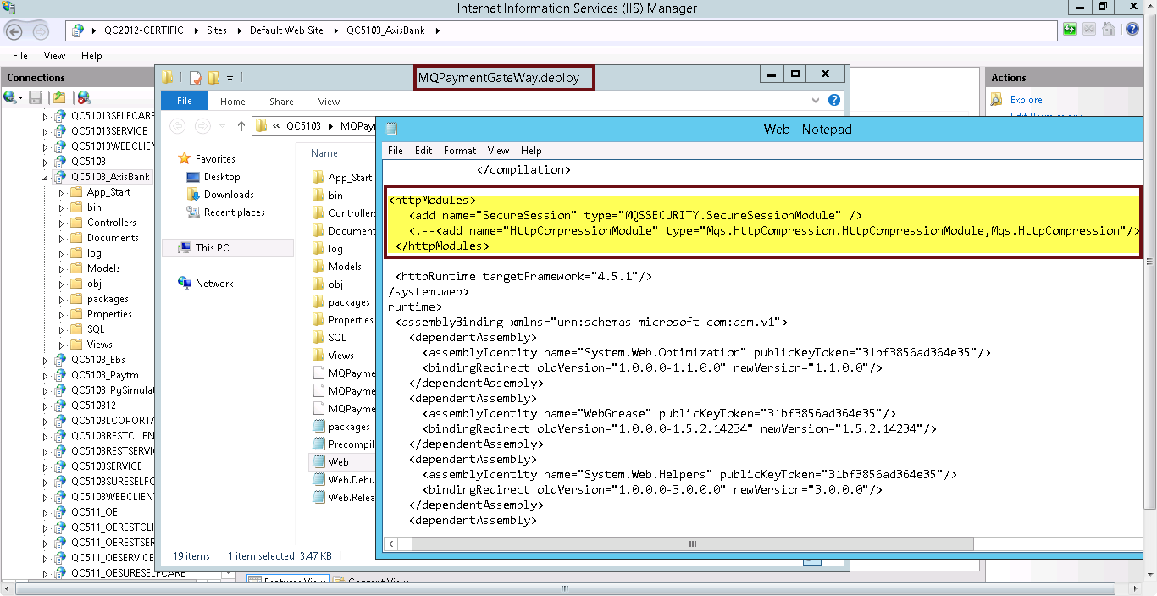
Screenshot 2: Showing the Internal Server Error cause for uncommenting the HTTP modules.
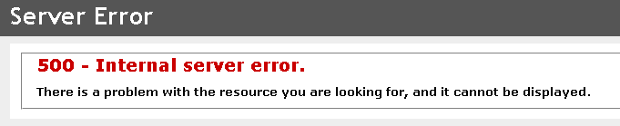

Merchant Key is Empty

Term | Details
Problem | Error Occurred at Gateway  Merchant Key is Empty
Cause | This is caused when sometimes the Merchant Gateway’s Key Details are not properly inserted into the Payment_Gateway_Merchant table even though the values are defined in the Merchant Gateway Configuration screen.
Solution | Make sure the Merchant Gateway’s Key Details are properly inserted into the Payment_Gateway_Merchant table.  If not inserted, then update the Key Details from backend in the Table.  (Column Names: MERCHANT_KEY, REQ_AUTH_KEY, RESP_AUTH_KEY, TEST_MERCHANT_KEY in Payment_Gateway_Merchant table).
Example:The following screenshot explains the above scenario:
Screenshot 1: Showing the Merchant Key is Empty error for the above scenario.
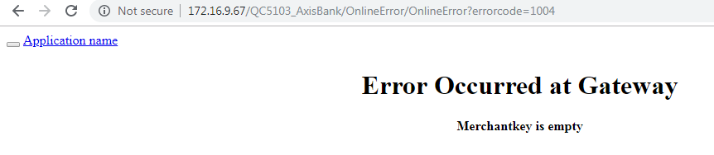

Incorrect Response URL

Term | Details
Problem | HTTP 404: The Resource Cannot be Found.  Incorrect Response URL.
Cause | This occurs when there is Incorrect Response URL in the RESPONSE_URL column of the Payment_Gateway_Merchant table.
Solution | Make sure the Response URL is correct in the Payment_Gateway_Merchant table.
Example:
The following screenshots explains the above scenario:
Screenshot 1: Showing the RESPONSE_URL column in the Payment_Gateway_Merchant table.
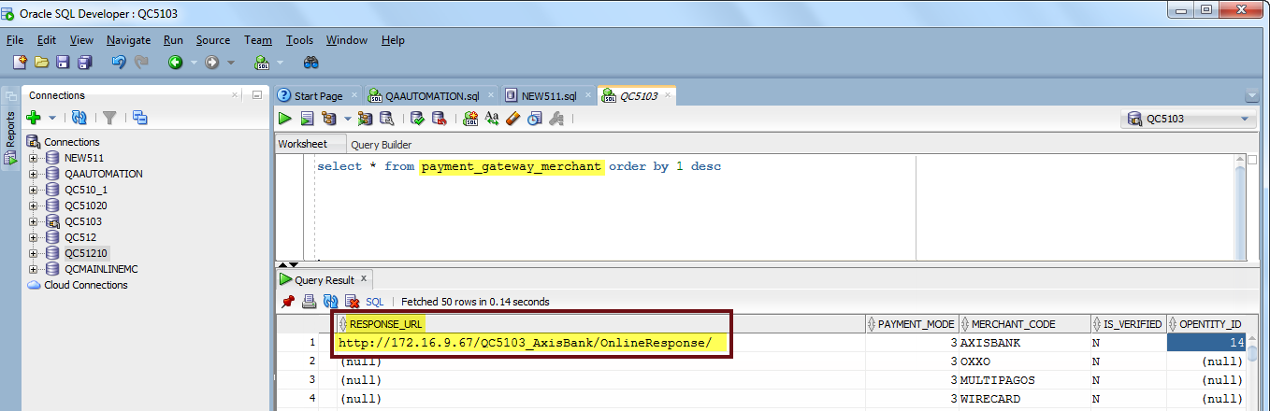
Screenshot 2: Showing the error caused due to the Incorrect Response URL in the table.
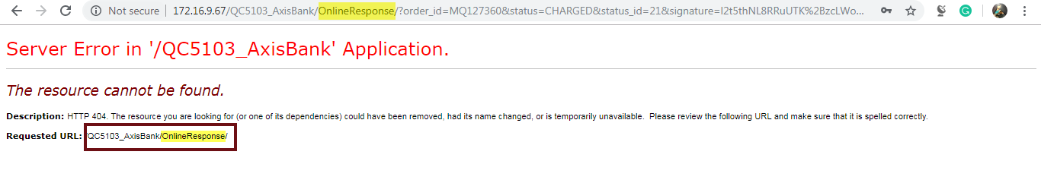

Payment Gateway Undefined

Term | Details
Problem | Default Payment Gateway is Not Defined
Cause | This occurs when the Payment Gateway is not mapped to the login User’s Operational Entity.
Solution | Verify whether the login User’s Operational Entity is having the Payment Gateway Mapping.  This can be verified in the Payment_Gateway_Merchant table. The OPENTITY_ID column should have the Operational Entity mapping ID.
Example:
The following screenshots explains the above scenario:
Screenshot 1:
Showing the Null value in the OPENTITY_ID Column of the Payment_Gateway_Merchant table, which implies, the Operational Entity is not mapped to the Payment Gateway.
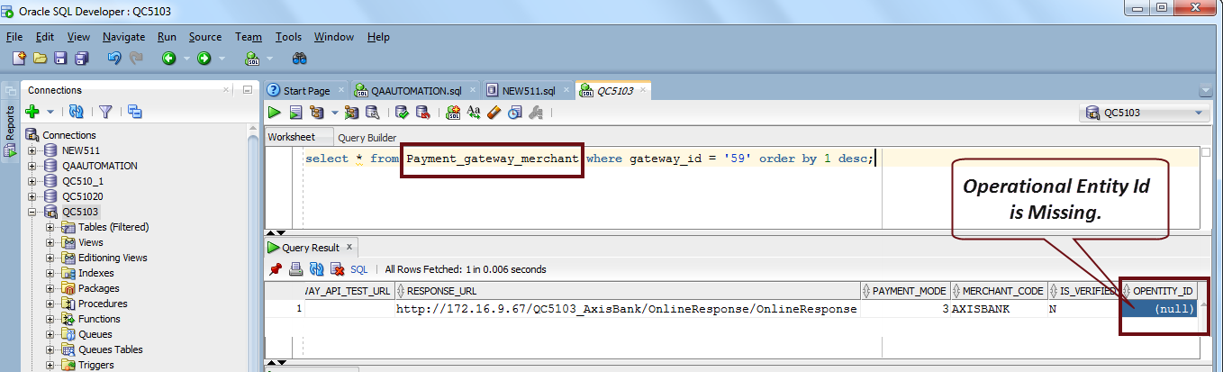
Screenshot 2:
Showing the Operational Entity mapping in the Payment_Gateway_Merchant table, which Implies, the Operational Entity is mapped to the Payment Gateway.

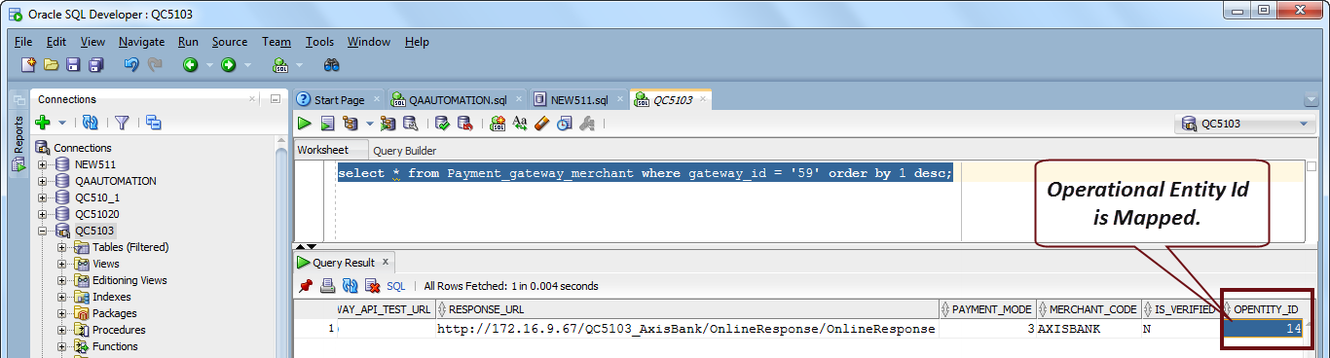
Screenshot 3: Showing the Error message when Payment Gateway is not mapped to the Operational Entity.
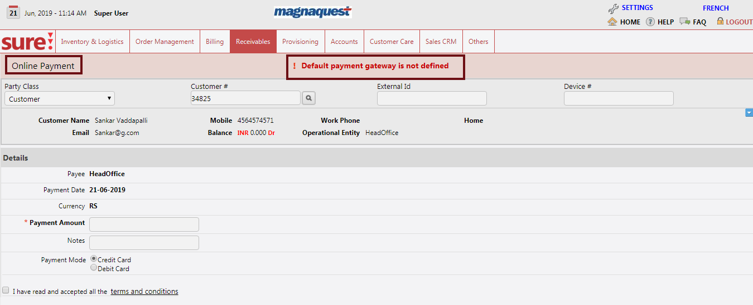

Contact Customer Care Executive

Term | Details
Problem | Error Occurred at Gateway  Please contact Customer care executive for more details
Cause | There could be many reasons for this generic error message statement. Some of the reasons are shown below. Mostly the reason could be of missing required Customer details.  - This occurs when the Currency is not mapped to the Payment Gateway.  - And also, when any of the Customer details like First Name, Last Name, Mobile Number, or Email Id is missing or not defined in the System.
Solution | - Make sure the Currency is mapped to the Payment Gateway in the Payment_Gateway_Currency table.  - Verify if all the required Customer details are properly defined in the System.
Example:
The following screenshots explains the above scenario:
Screenshot 1: Showing Payment_Gateway_Currency table without definition of the Currency.
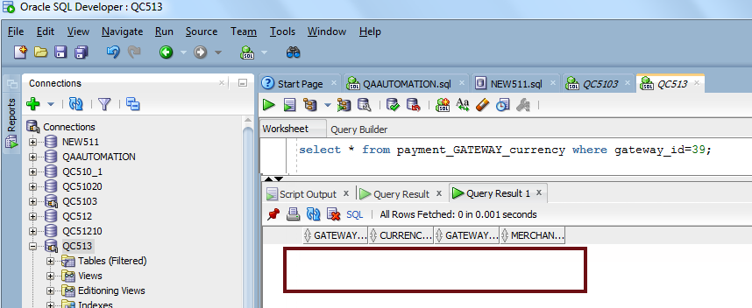
Screenshot 2: Showing Currency mapping to the Payment Gateway in Payment_Gateway_Currency table.
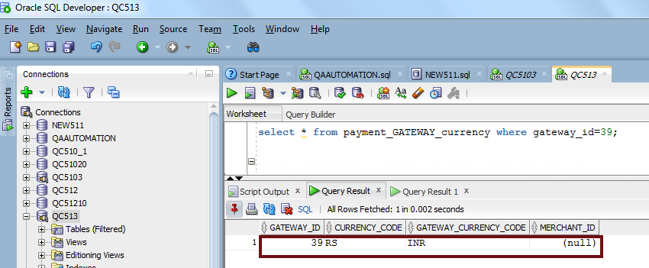

Screenshot 3:
Showing the Error message caused for the above reasons.
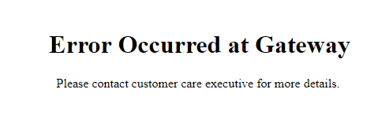

SPG tag checking :
Need to check “SPG” tag in the Web config file of Native and Selfcare deploy.It Should enable for standard payment gateway and disable for Normal gateway.
standard payment gateway having spg tag, and and its based on gateway dll.. like suppose atom pg is in standard pg then will have atompg.dll .. so any changes on request/response may required on dll changes.
normal payment getway mostly developed in aspx (old technologies), doesn't requied spg tag, and deploy changes required if we do any changes on request/response.
Note:From 5_13 onwards, Simulator has also developed as Standard Payment Gateway.

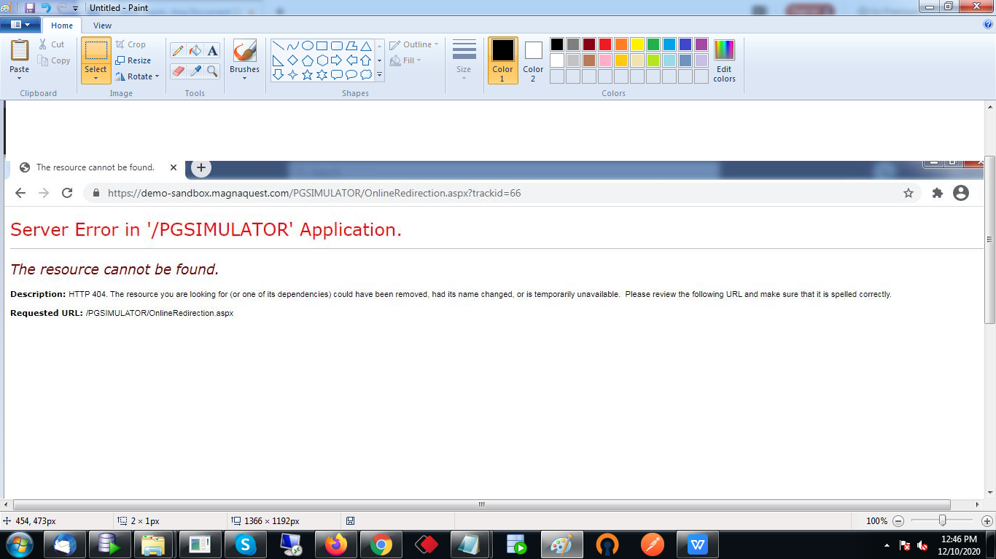

Support
For further information or any technical support, please contact:
E-mail: mqssupport@magnaquest.com, bcrm.support@magnaquest.com
Phone: +91 9866558383

Copyright

This document is the property of, and is proprietary to Magnaquest Technologies Limited (Magnaquest). It is not to be disclosed in whole or in part without the expressed written authorization of Magnaquest, and shall not be duplicated or used, in whole or in part, and shall be returned to Magnaquest upon request.
Copyright © 2019 Magnaquest Technologies Limited (Magnaquest). All rights reserved. All trademarks, trade names, service marks, and logos referenced herein belong to their respective companies.

